

**DEPARTMENT OF ELECTRONIS**

BATCH : Class B.Sc computer(Entire) - I

SEAT NO. /PRN : DATE :

* **TITLE : Addition of two Numbers**

Step 1 : open 8085 simulator

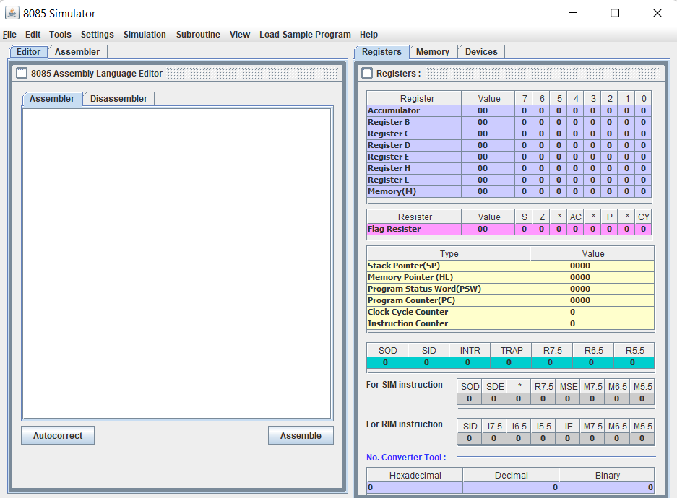

Step 2 : write a program on editor window

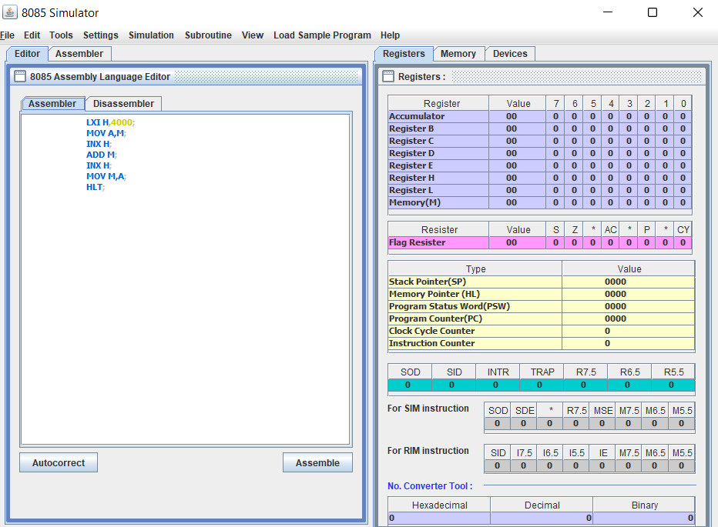

Step 3 : Assamble the program

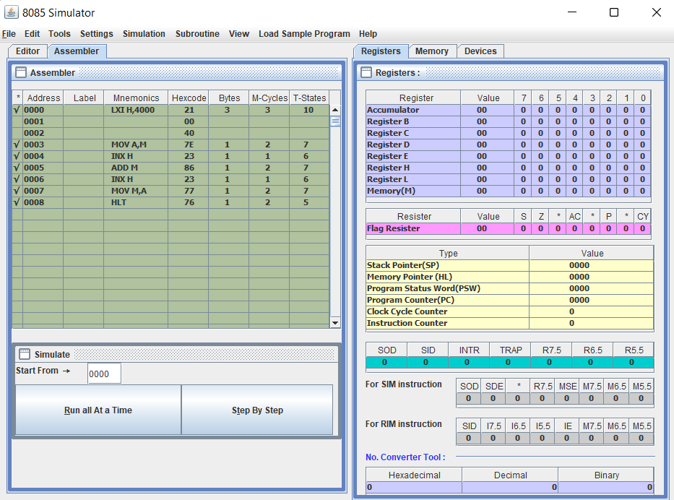

Step 4 : Store the value in memory location

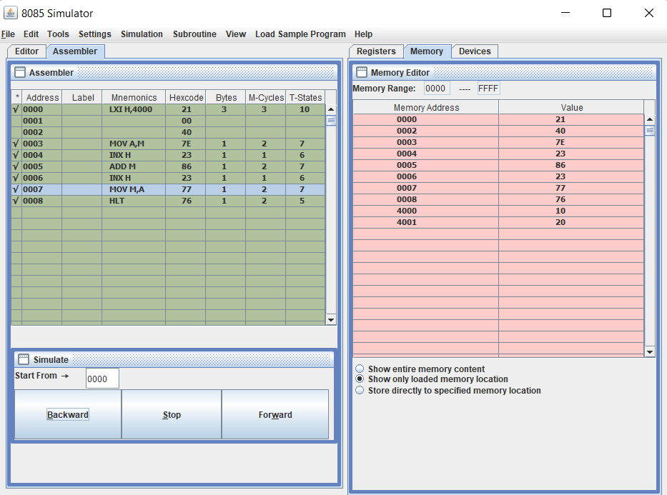

Step 5 : Execute program step by step

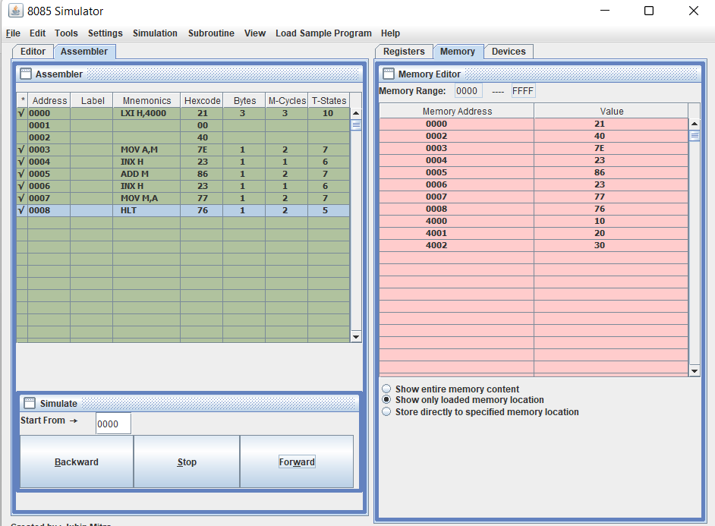

Step 6 : output is store in define memory location as below fig





**DEPARTMENT OF ELECTRONIS**

BATCH : Class B.Sc computer(Entire) - I

SEAT NO. /PRN : DATE :

* **TITLE : Subtraction of two numbers**

Step 1 : open 8085 simulator



Step 2 : write a program on editor window

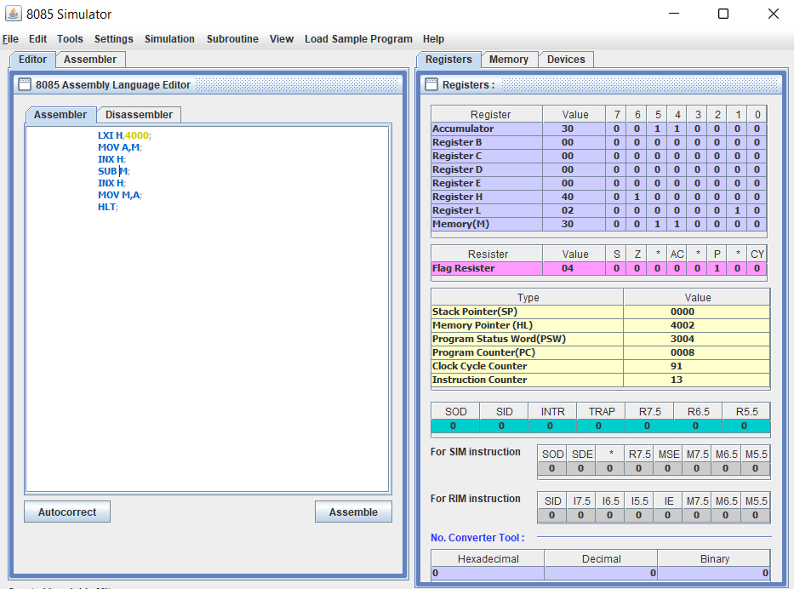

Step 3 : Assamble the program

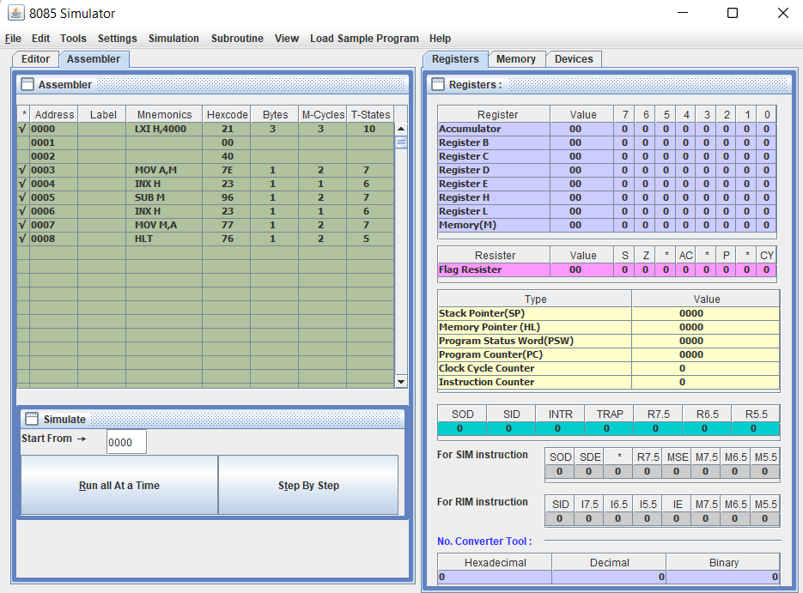

Step 4 : Store the value in memory location

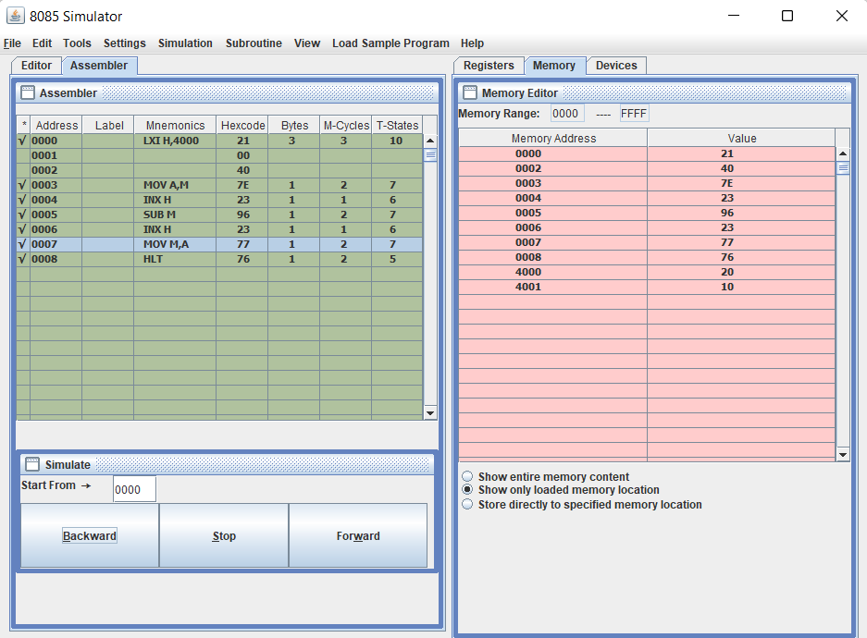

Step 5 : Execute program step by step



Step 6 : output is store in define memory location as below fig

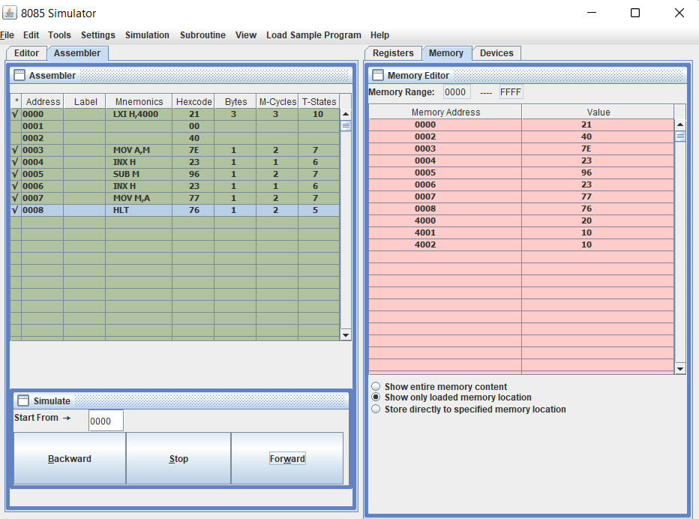



**DEPARTMENT OF ELECTRONIS**

BATCH : Class B.Sc computer(Entire) - I

SEAT NO. /PRN : DATE :

* **TITLE : Multiplication of two numbers**

Step 1 : open 8085 simulator



Step 2 : write a program on editor window

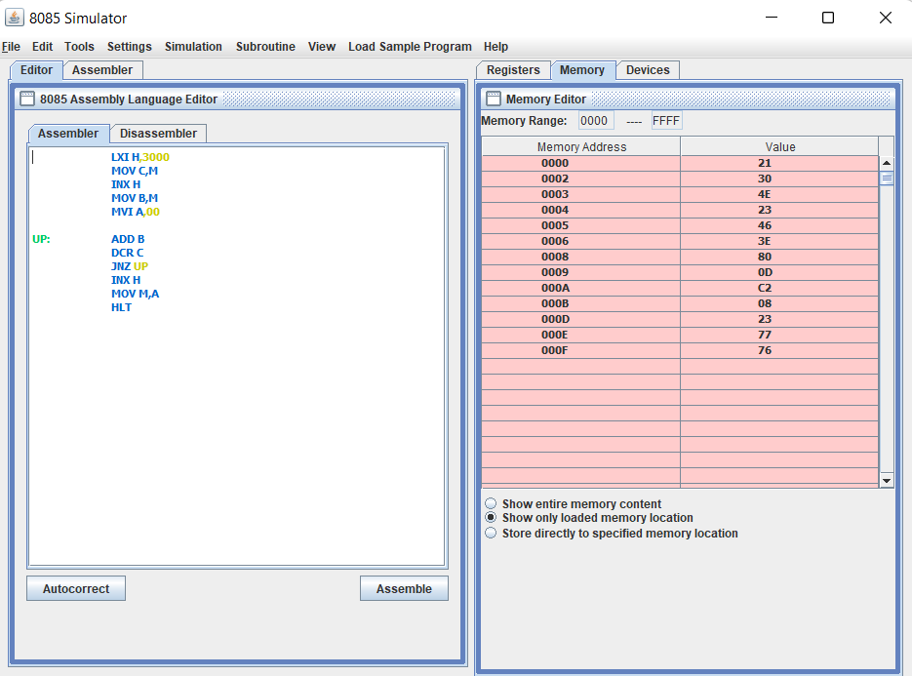

Step 3 : Assamble the program

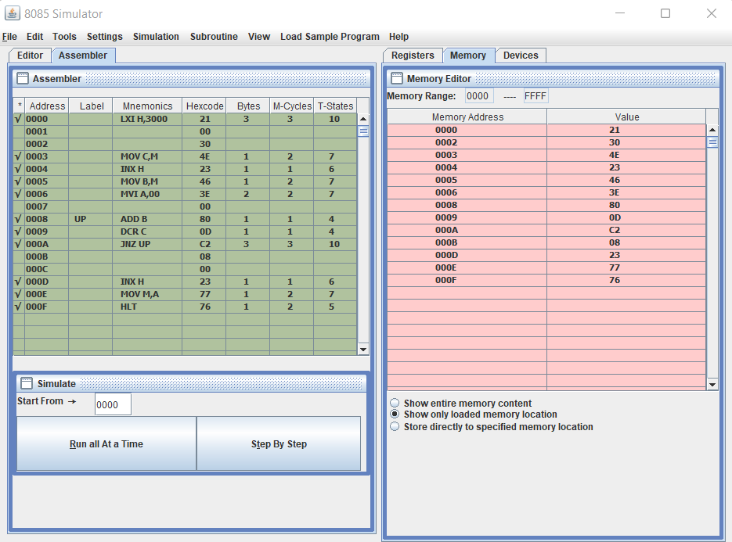

Step 4 : Store the value in memory location

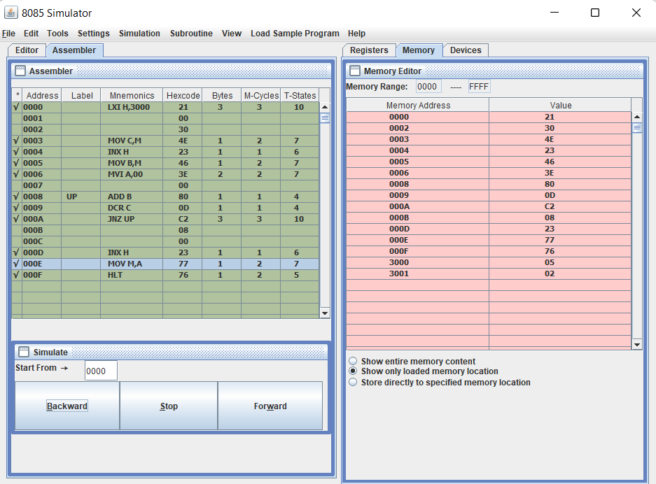

Step 5 : Execute program step by step

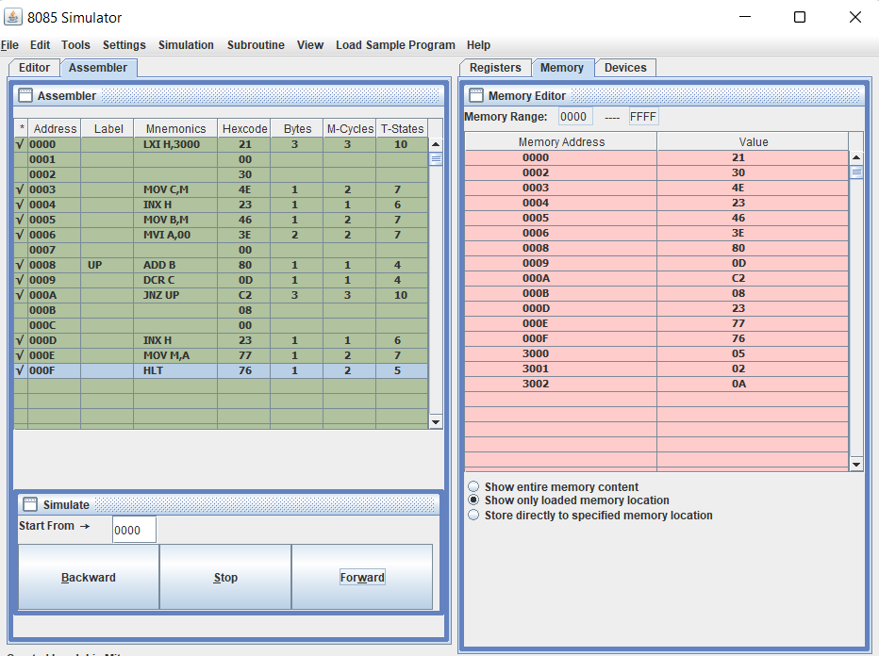

Step 6 : output is store in define memory location as below fig





**DEPARTMENT OF ELECTRONIS**

BATCH : Class B.Sc computer(Entire) - I

SEAT NO. /PRN : DATE :

* **TITLE : Division of two numbers**

Step 1 : open 8085 simulator



Step 2 : write a program on editor window

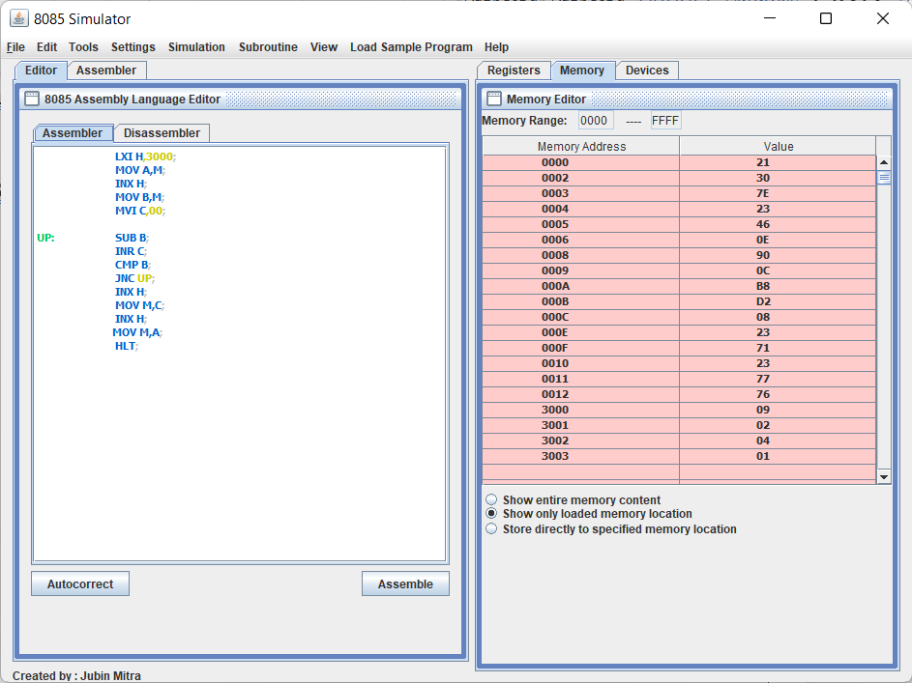

Step 3 : Assamble the program

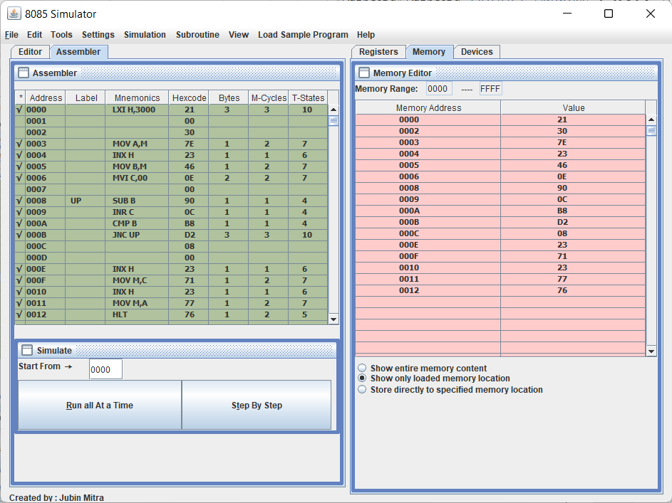

Step 4 : Store the value in memory location

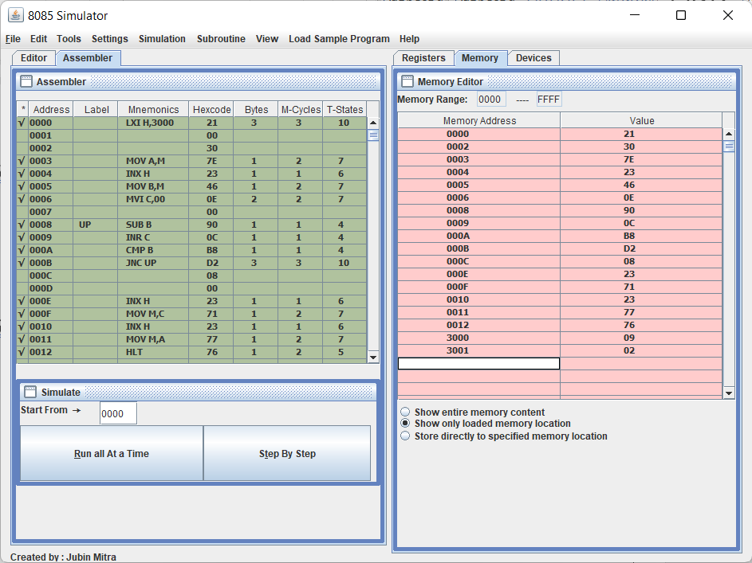

Step 5 : Execute program step by step

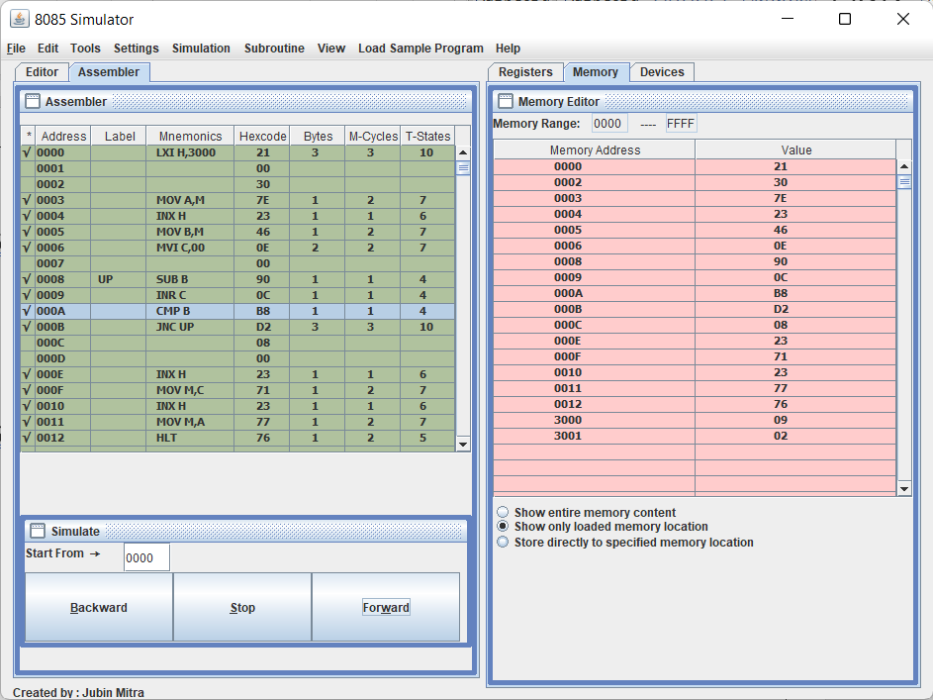

Step 6 : output is store in define memory location as below fig

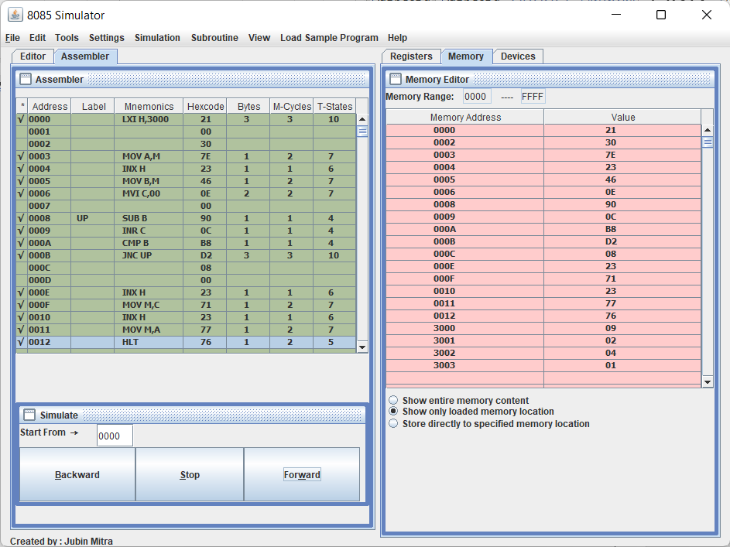



**DEPARTMENT OF ELECTRONIS**

BATCH : Class B.Sc computer(Entire) - I

SEAT NO. /PRN : DATE :

* **TITLE : Block transfer**

Step 1 : open 8085 simulator



Step 2 : write a program on editor window

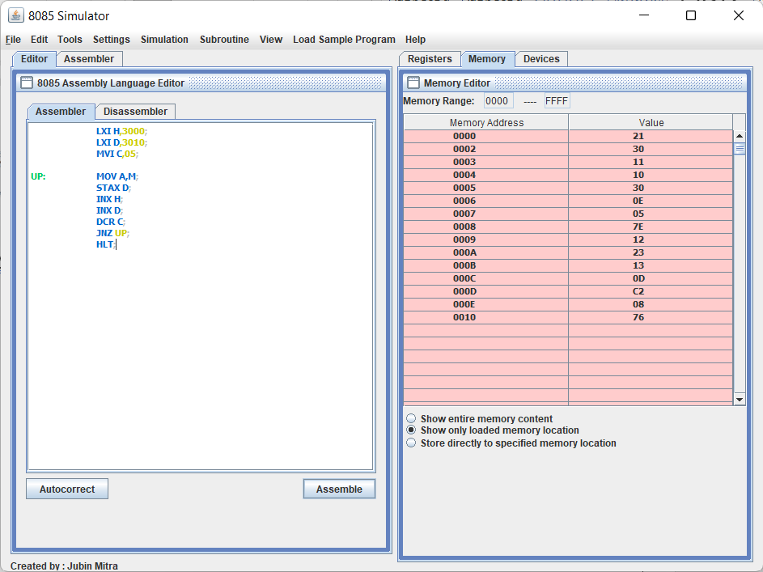

Step 3 : Assemble the program

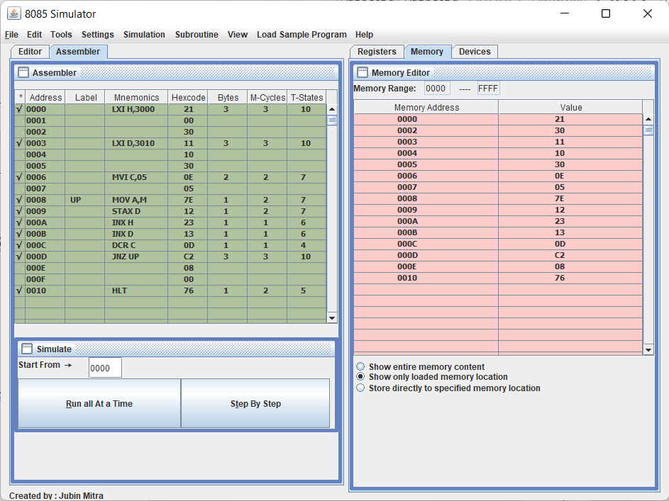

Step 4 : Store the value in memory location

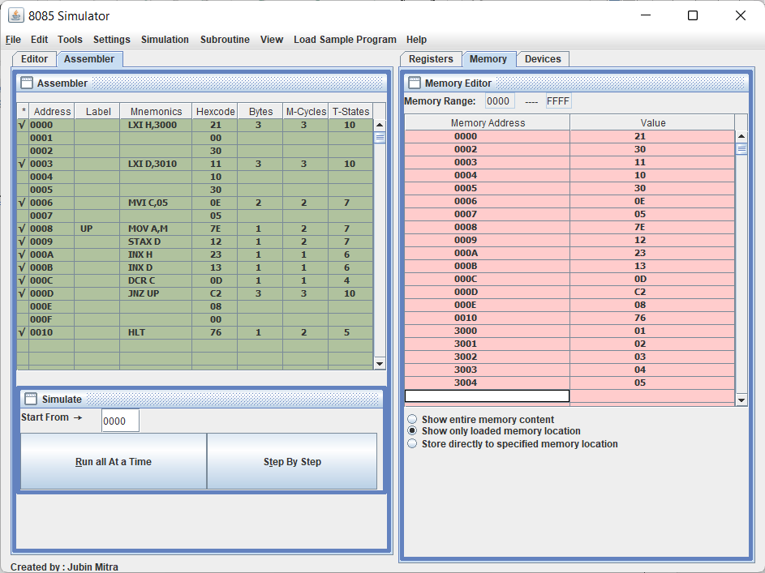

Step 5 : Execute program step by step

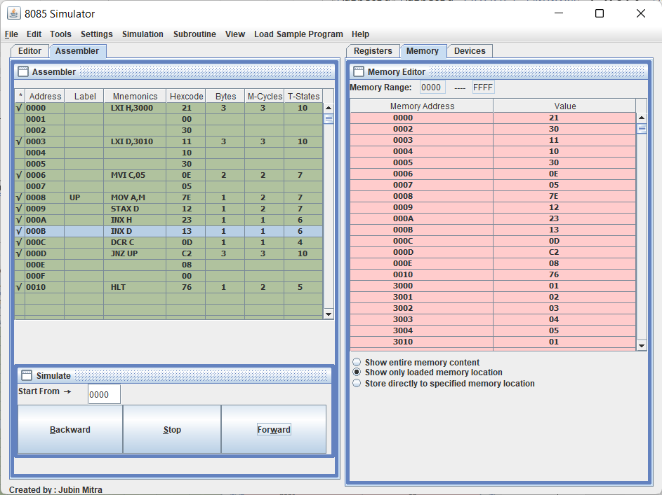

Step 6 : output is store in define memory location as below fig

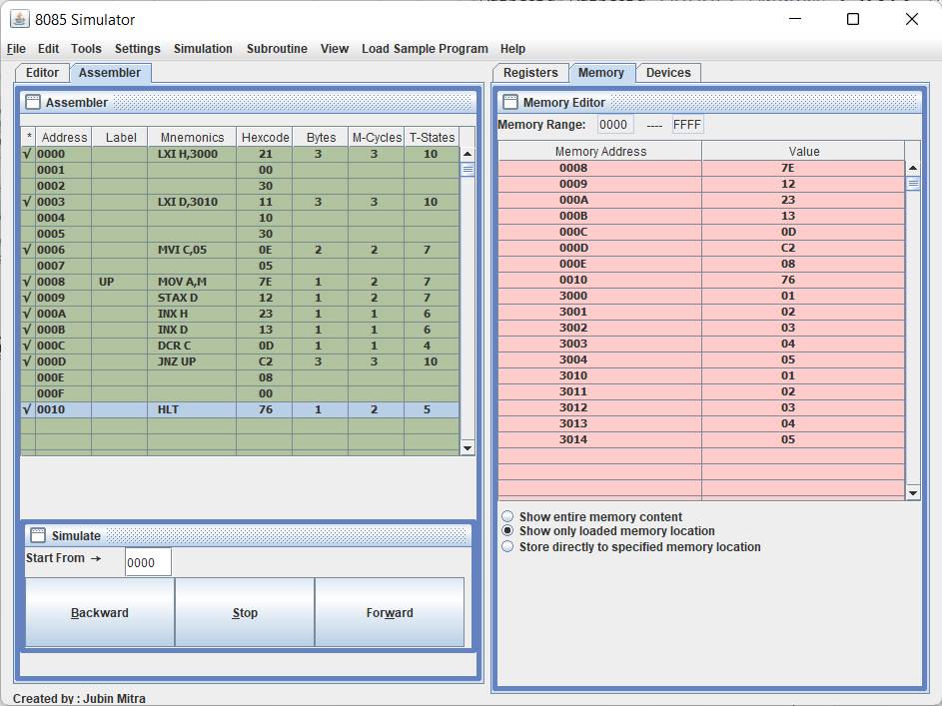



**DEPARTMENT OF ELECTRONIS**

BATCH : Class B.Sc computer(Entire) - I

SEAT NO. /PRN : DATE :

* **TITLE : Block exchange**

Step 1 : open 8085 simulator



Step 2 : write a program on editor window

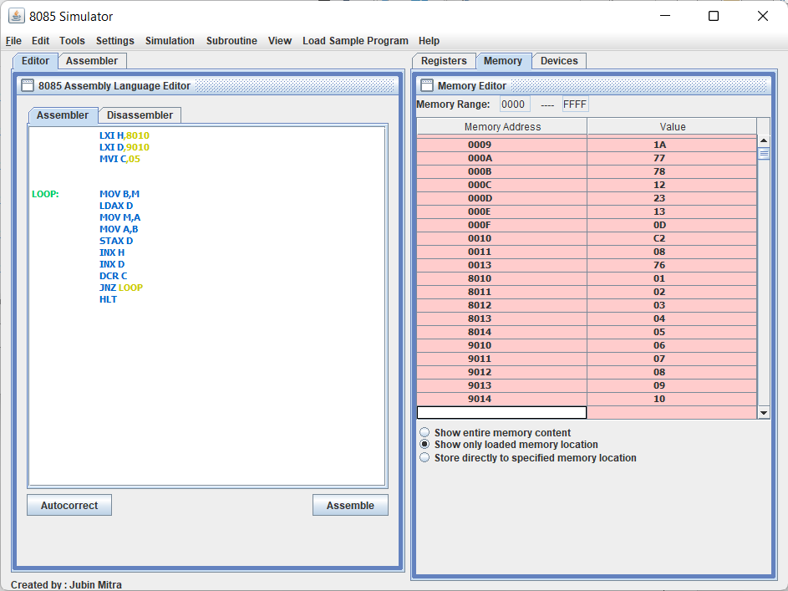

Step 3 : Assemble the program

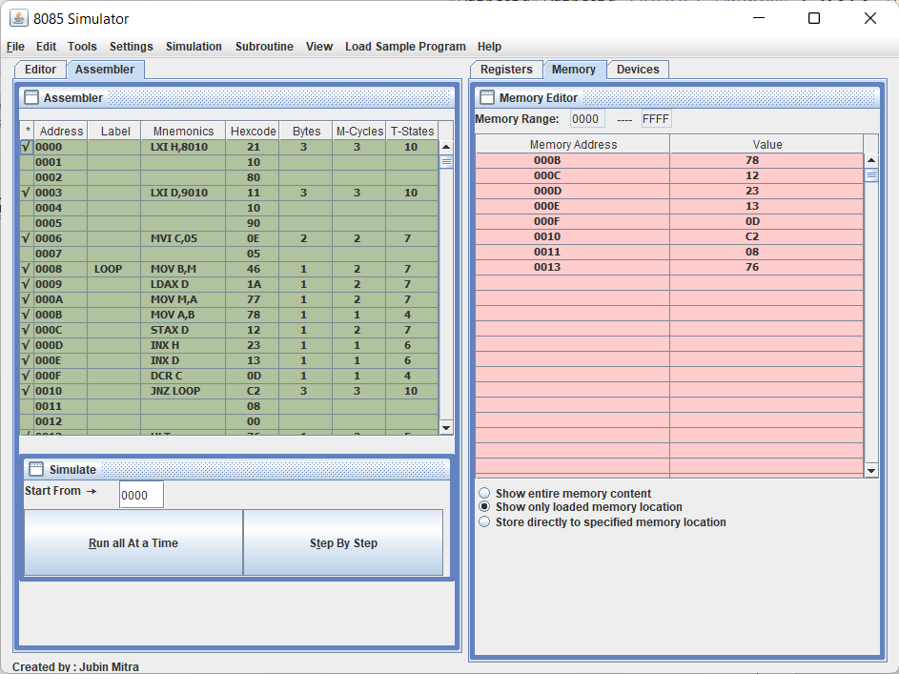

Step 4 : Store the value in memory location

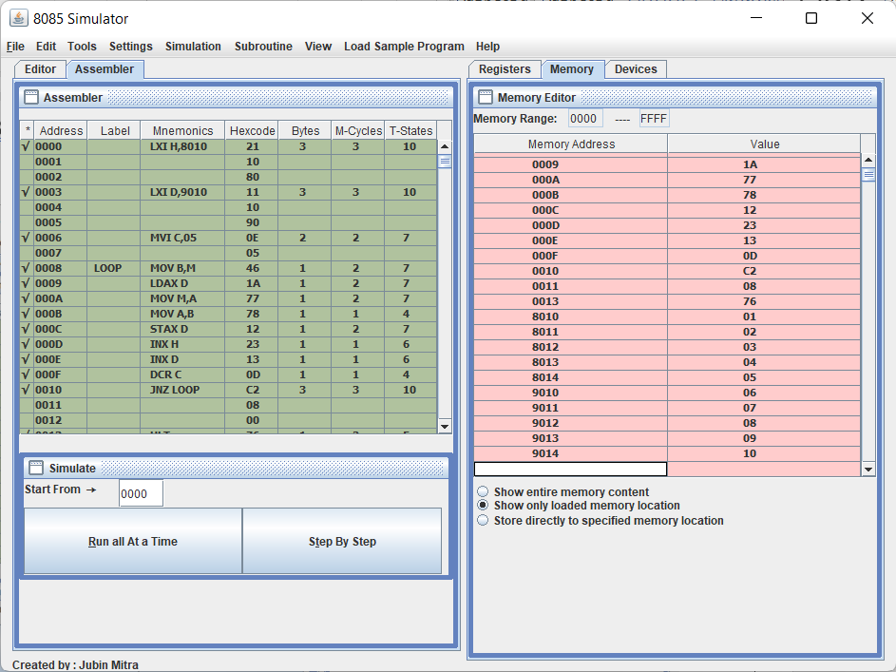

Step 5 : Execute program step by step



Step 6 : output is store in define memory location as below fig

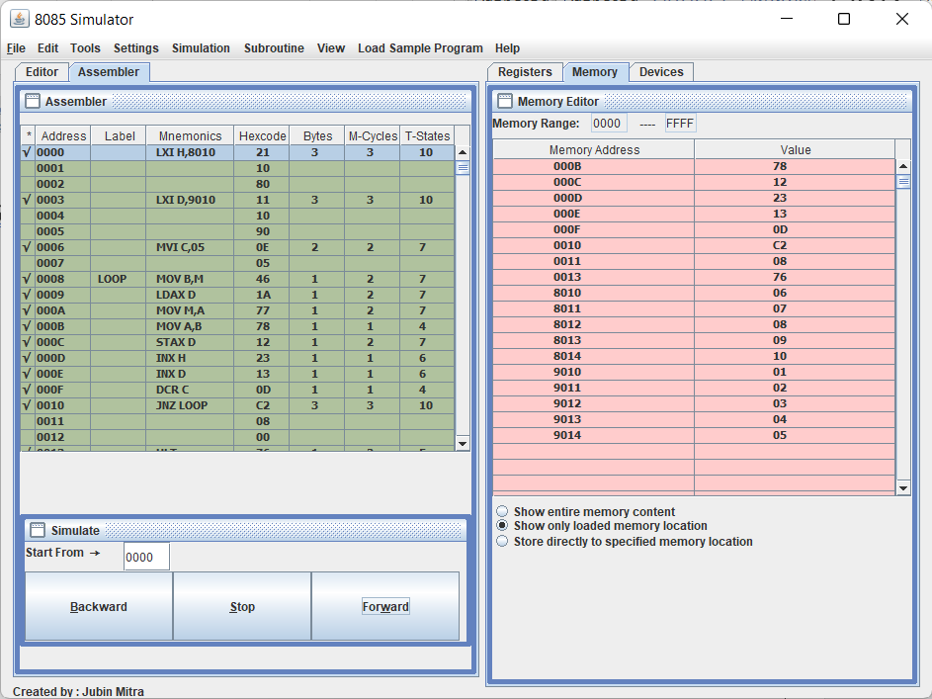



**DEPARTMENT OF ELECTRONIS**

BATCH : Class B.Sc computer(Entire) - I

SEAT NO. /PRN : DATE :

* **TITLE : Find large number in series**

Step 1 : open 8085 simulator



Step 2 : write a program on editor window

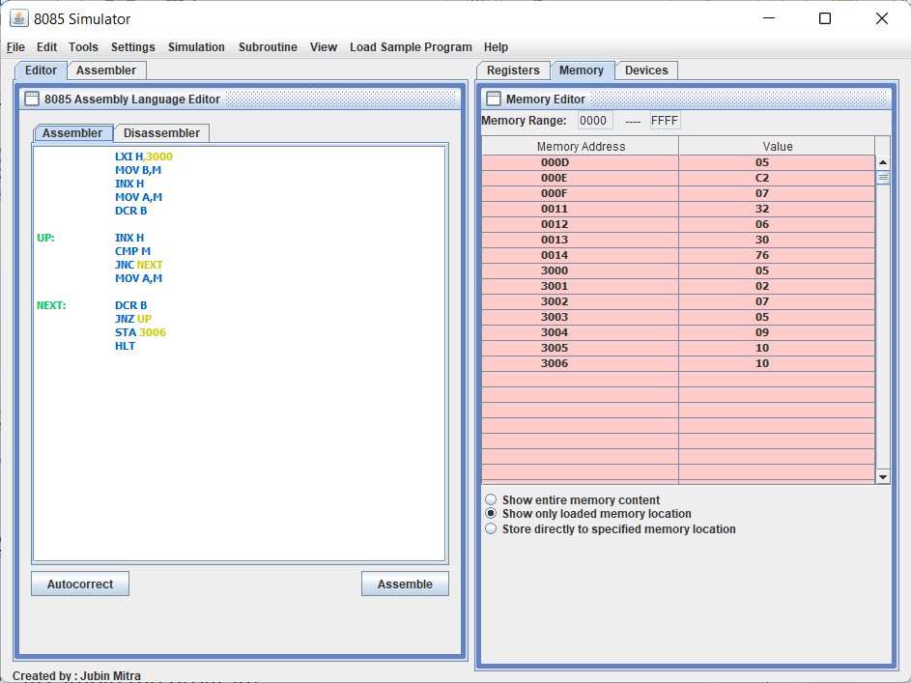

Step 3 : Assemble the program

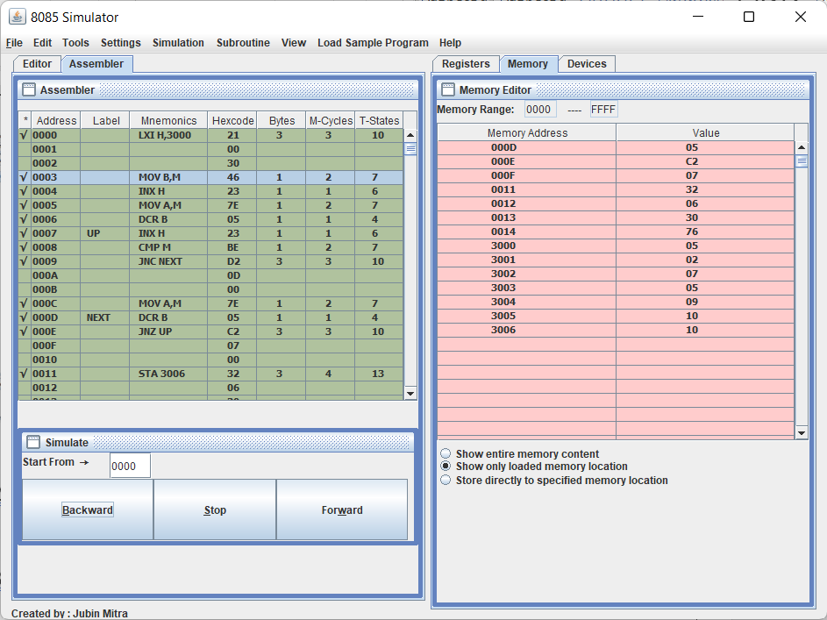

Step 4 : Store the value in memory location

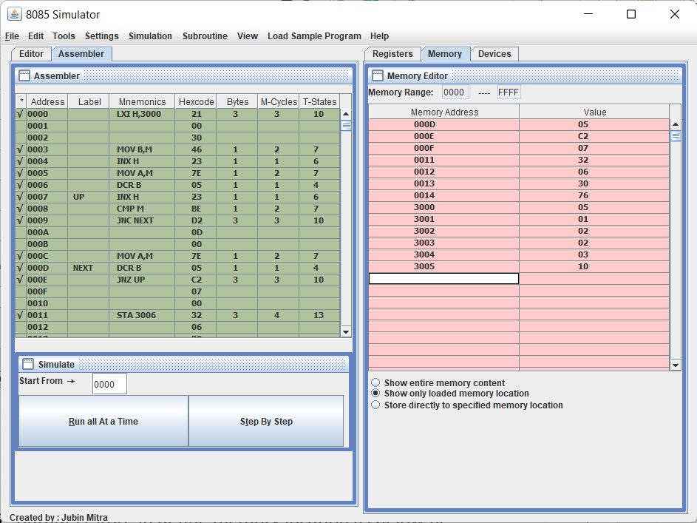

Step 5 : Execute program step by step

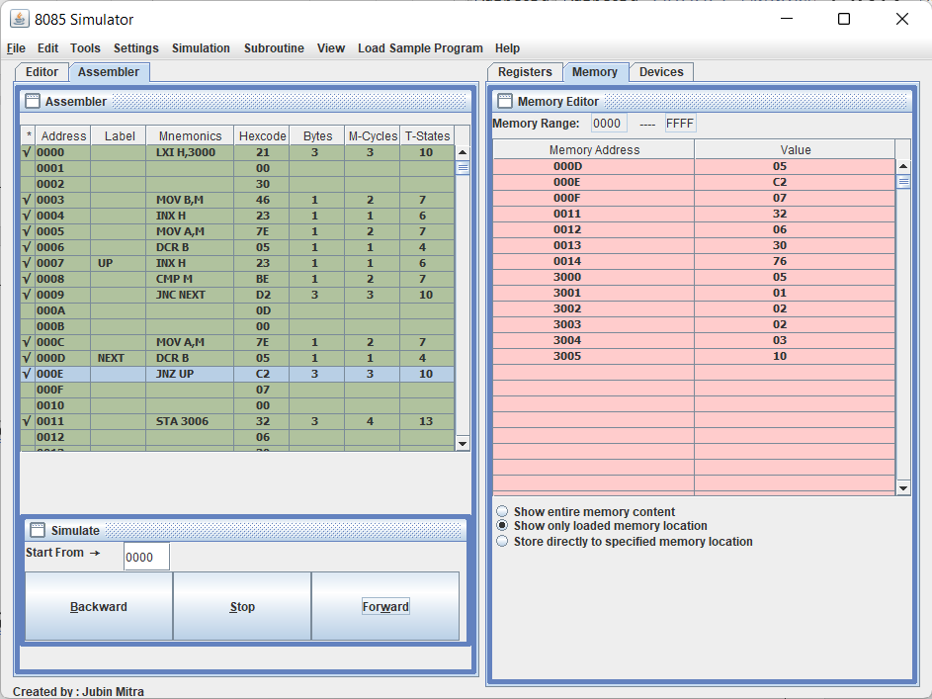

Step 6 : output is store in define memory location as below fig

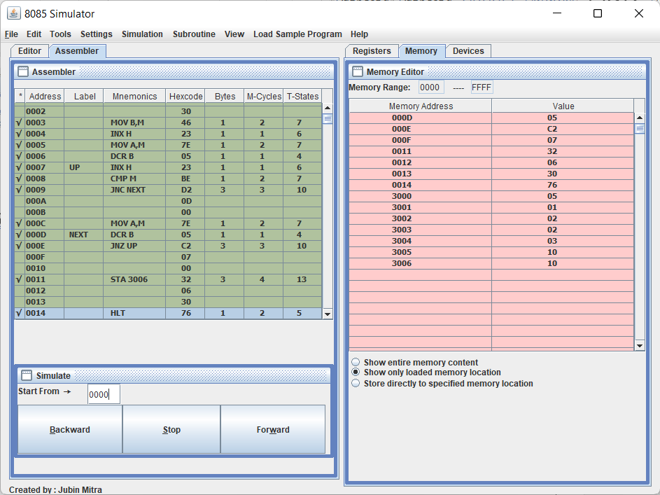



**DEPARTMENT OF ELECTRONIS**

BATCH : Class B.Sc computer(Entire) - I

SEAT NO. /PRN : DATE :

* **TITLE : Find small number in series**

Step 1 : open 8085 simulator



Step 2 : write a program on editor window

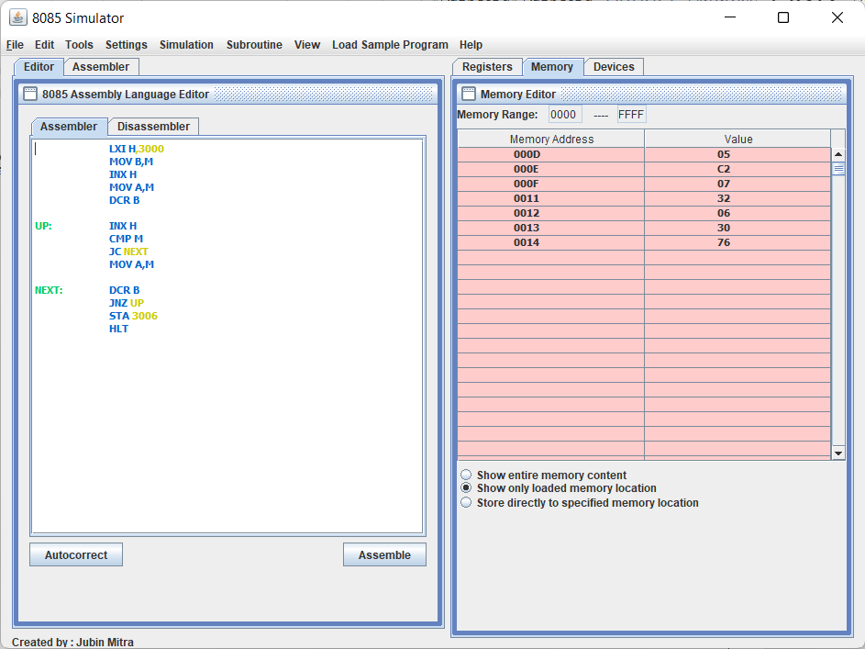

Step 3 : Assemble the program

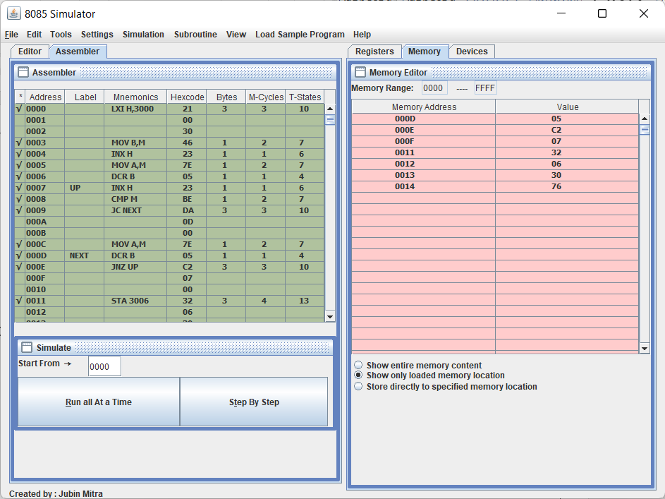

Step 4 : Store the value in memory location

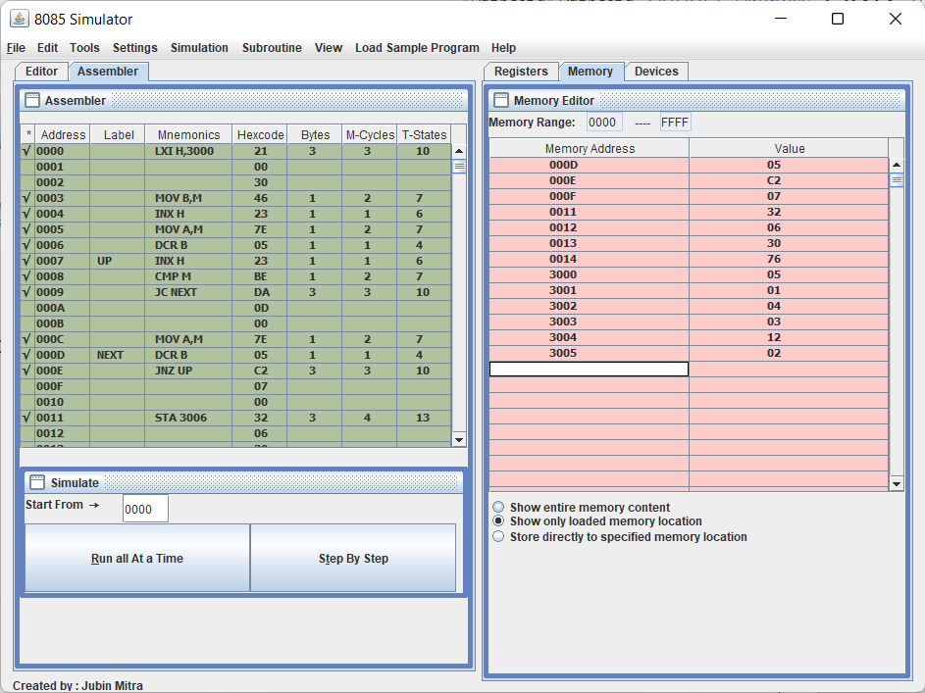

Step 5 : Execute program step by step

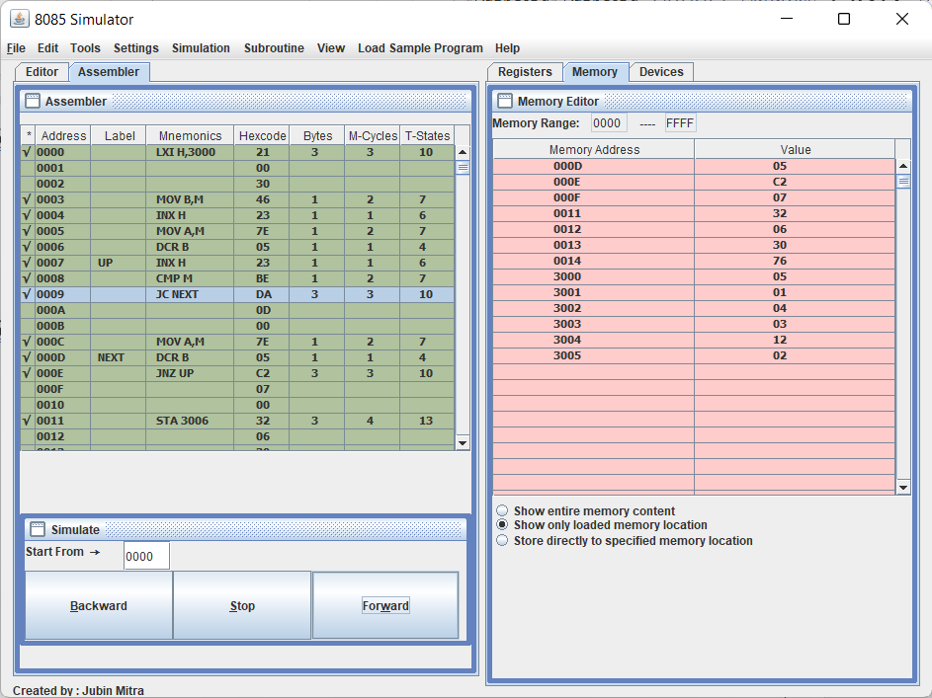

Step 6 : output is store in define memory location as below fig

